**THE AVICENNA SCHOOL CO-ED CAMPUS**

**FINAL TERM ASSESSMENT 2024**

**Science**

|  |  |
| --- | --- |
| **Written exam 60** |  |
| **Class test 40** |  |
| **Total 100** |  |

**Name: __________________ Roll # _____________ Date: ________________**

**Section A**

**Q1: Label and colour the diagram. /6**

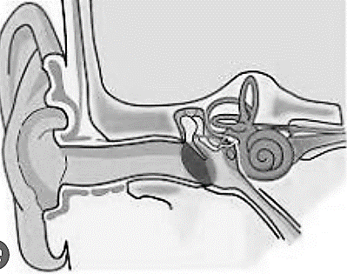

**Q2: Fill in the blanks. /5**

1. **_____________ are lovely and often colorful.**
2. **Sounds are made by ______________.**
3. **There are over _________ man-made _____________ in the space.**
4. **Moon takes __________ days to rotate once on its axis.**
5. **Fruits grow from ____________.**
6. **A drum skin hit gently makes a _______________ sound.**
7. **_________________ are scientist who study space and planets.**
8. **The first man to walk on moon was ____________________**
9. **____________ usually have a hard covering.**
10. **Young plants grown from seeds are called _______________**

**Q3: Find the odd one out in each list below. /5**

1. **Ginger, potato, onion, orange**
2. **Sun, moon, star, water**
3. **Carrot, turnip, radish, cauliflower**
4. **Mercury, Venus, earth, ginger**
5. **Drum, guitar, violin, rock**

**Q4: State whether true or false. /5**

1. **Very loud sound can damage hearing. ___________**
2. **Tomato is really a fruit. ______________**
3. **The moon orbits around the sun. _________**
4. **Our earth is the part of the solar system. _________**
5. **Lettuce is a root vegetable. ____________**
6. **Seeds can be dispersed by a cow. ___________**
7. **Sound can travel through wood. __________**
8. **Light travel faster than sound. ____________**
9. **Shadows are longer in night. __________**
10. **There are 8 planets in the solar system. ____________**

**Q5: In the given table draw and list the vegetables under the heading. /5**

|  |  |  |  |  |
| --- | --- | --- | --- | --- |
| **leaf bud** | **leaves** | **stems** | **roots** | **Flower bud** |

**Q6: Draw and explain the process of germination. /10**

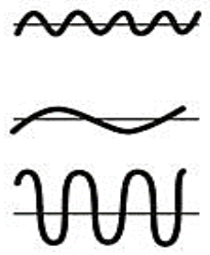**Q7: Look at the different vibrations and write their appropriate names. /4**

**_____________________________________**

**______________________________________**

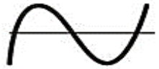**______________________________________**

**_______________________________________**

**Section B**

* **Short answers. /10**

1. **What does a plant produce?**

**________________________________________________________________________________________________________________________________**

1. **How many planets are there in the solar system?**

**________________________________________________________________________________________________________________________________**

1. **How is sound produced?**

**________________________________________________________________________________________________________________________________**

1. **What is light explain?**

**________________________________________________________________________________________________________________________________**

1. **Write the names of any 2 leaf bud plants.**

**________________________________________________________________________________________________________________________________**

1. **Write the speed of light.**

**________________________________________________________________________________________________________________________________**

1. **How sounds are useful?**

**________________________________________________________________________________________________________________________________**

1. **Describe moon in one line.**

**________________________________________________________________________________________________________________________________**

1. **Write the usage of a telescope.**

**________________________________________________________________________________________________________________________________**

1. **What is stomata?**

**________________________________________________________________________________________________________________________________**

* **Detail answers. /10**

1. **Write 3 facts of Moon.**

**__________________________________________________________________________________________________________________________________________________________________________________________**

1. **What are luminous objects? Name any five luminous objects.**

**__________________________________________________________________________________________________________________________________________________________________________________________**

1. **Explain what is meant by transparent, translucent and opaque material. Give on example of each.**

**______________________________________________________________________________________________________________________________________________________________________________________________________________________________________________________________________________________________________________________**

1. **Are shadows longer in morning or at midday? Explain why?**

**__________________________________________________________________________________________________________________________________________________________________________________________**

1. **What are the different ways in which seeds can be dispersed?**

**____________________________________________________________________________________________________________________________**